ADDB7311

ICE Task 3 - PL/SQL Pg 101

ST10305921 – Zoe Heyneke

Create tables:

* Event Table:

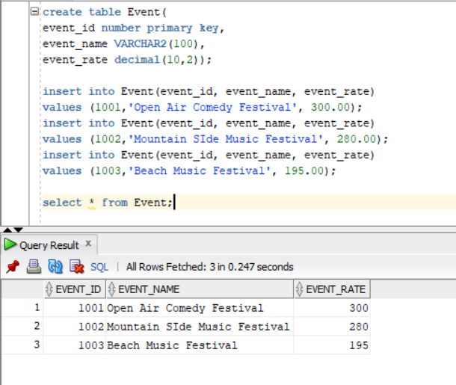

* Artists Table:

* Bookings Table:

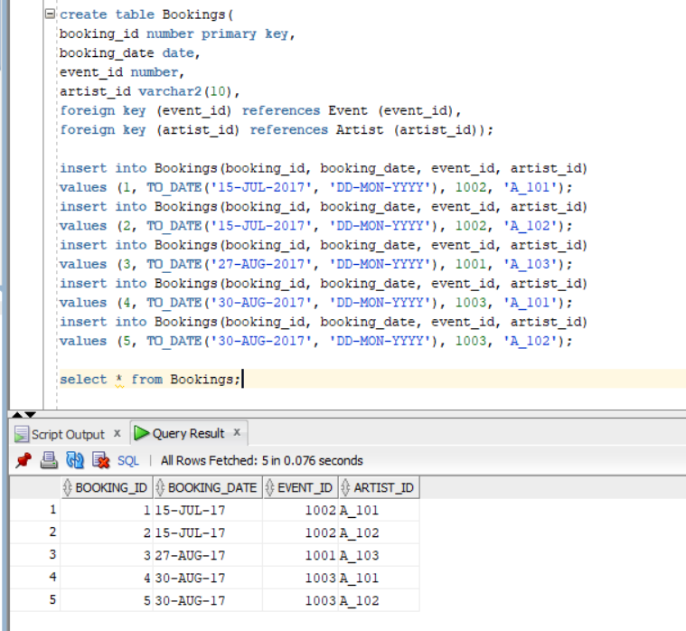

create table Event(

event_id number primary key,

event_name VARCHAR2(100),

event_rate decimal(10,2));

insert into Event(event_id, event_name, event_rate)

values (1001,'Open Air Comedy Festival', 300.00);

insert into Event(event_id, event_name, event_rate)

values (1002,'Mountain SIde Music Festival', 280.00);

insert into Event(event_id, event_name, event_rate)

values (1003,'Beach Music Festival', 195.00);

select * from Event;

create table Artist(

artist_id varchar2(10) primary key,

artist_name varchar2(100),

artist_email varchar2(100));

insert into Artist (artist_id, artist_name, artist_email)

values ('A_101', 'Max Trillion', 'maxt@isat.com');

insert into Artist (artist_id, artist_name, artist_email)

values ('A_102', 'Music Mayhem', 'mayhem@ymail.com');

insert into Artist (artist_id, artist_name, artist_email)

values ('A_103', 'LOL Man', 'lol@isat.com');

select * from Artist;

create table Bookings(

booking_id number primary key,

booking_date date,

event_id number,

artist_id varchar2(10),

foreign key (event_id) references Event (event_id),

foreign key (artist_id) references Artist (artist_id));

insert into Bookings(booking_id, booking_date, event_id, artist_id)

values (1, TO_DATE('15-JUL-2017', 'DD-MON-YYYY'), 1002, 'A_101');

insert into Bookings(booking_id, booking_date, event_id, artist_id)

values (2, TO_DATE('15-JUL-2017', 'DD-MON-YYYY'), 1002, 'A_102');

insert into Bookings(booking_id, booking_date, event_id, artist_id)

values (3, TO_DATE('27-AUG-2017', 'DD-MON-YYYY'), 1001, 'A_103');

insert into Bookings(booking_id, booking_date, event_id, artist_id)

values (4, TO_DATE('30-AUG-2017', 'DD-MON-YYYY'), 1003, 'A_101');

insert into Bookings(booking_id, booking_date, event_id, artist_id)

values (5, TO_DATE('30-AUG-2017', 'DD-MON-YYYY'), 1003, 'A_102');

select * from Bookings;

* Display the artist name and the booking date for Event ID equal to 1001

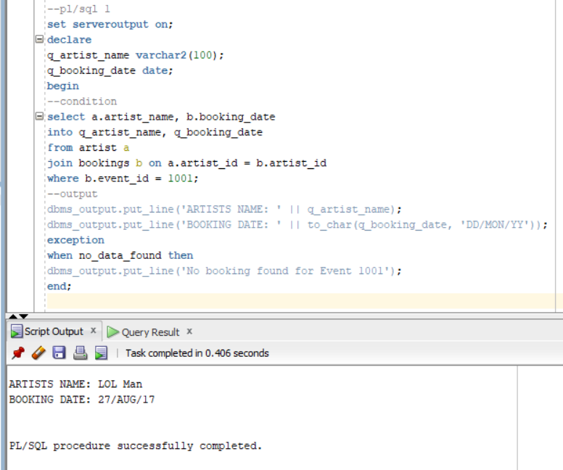

--pl/sql 1

set serveroutput on;

declare

q_artist_name varchar2(100);

q_booking_date date;

begin

--condition

select a.artist_name, b.booking_date

into q_artist_name, q_booking_date

from artist a

join bookings b on a.artist_id = b.artist_id

where b.event_id = 1001;

--output

dbms_output.put_line('ARTISTS NAME: ' || q_artist_name);

dbms_output.put_line('BOOKING DATE: ' || to_char(q_booking_date, 'DD/MON/YY'));

exception

when no_data_found then

dbms_output.put_line('No booking found for Event 1001');

end;

* 10% discount on events that cost over R250

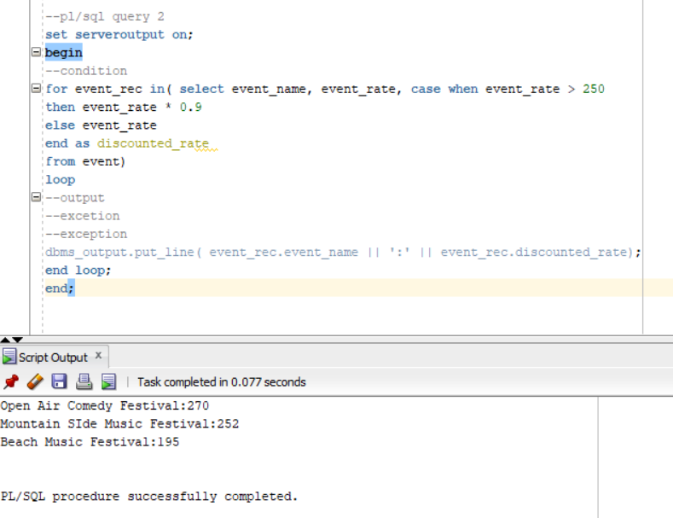

--pl/sql query 2

set serveroutput on;

begin

--condition

for event_rec in( select event_name, event_rate, case when event_rate > 250

then event_rate * 0.9

else event_rate

end as discounted_rate

from event)

loop

--output

--excetion

--exception

dbms_output.put_line( event_rec.event_name || ':' || event_rec.discounted_rate);

end loop;

end;